The Connection Between Health Equity and Malnutrition: Identifying and Sharing Solutions From a Multi-Stakeholder Roundtable
MAY 2022
Malnutrition Connection
Providing Malnutrition Awareness and Advocacy Information to Share

Despite substantial awareness of the burden of malnutrition, rates of diagnosis and identification of malnutrition are low, leaving many malnourished patients potentially undiagnosed and untreated. This phenomenon is magnified in underserved communities, contributing to even larger health disparities.
To discuss and identify solutions for the connections between health equity, hospital malnutrition care, and food insecurity, the Malnutrition Quality Improvement Initiative (MQii) recently convened a Roundtable featuring a multi-stakeholder group of healthcare leaders and national experts.
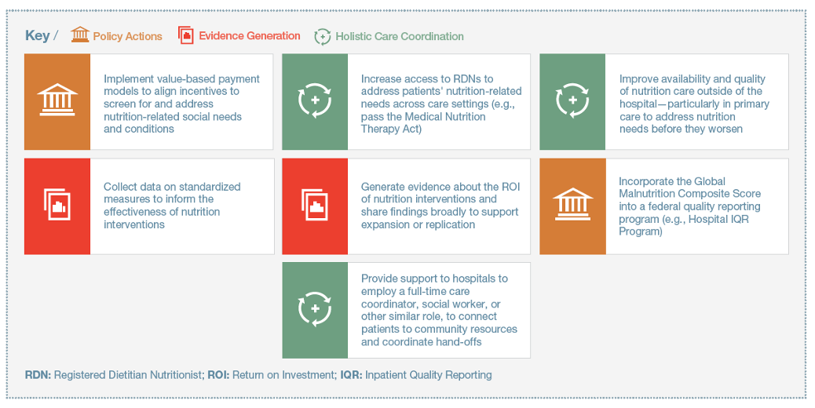
Participants focused on pathways to manage and address malnutrition, food insecurity, and health disparities across transitions of care while leveraging malnutrition composite measure performance data, hospital and community partnerships, and relevant experts all working toward the same goal. Solutions that participants considered to be top priorities for action are presented in the figure below.
Reminder: As highlighted in the April Malnutrition Connection, you have the opportunity to submit a Comment to CMS supporting the inclusion of the Global Malnutrition Composite Score in its Hospital Inpatient Prospective Payment System (IPPS) rule for FY 2023!
The Deadline is June 17.

You can submit electronic comments at this comment period link. (Select “COMMENT” and follow the instructions).
- Please refer to file code CMS-1771-P in your comments.
- To help you write your comments: check out this summary from Avalere Health and this action alert from Defeat Malnutrition Today for detailed suggestions.
- Be sure to share this Defeat Malnutrition Today action alert with your networks to increase comments submitted.
The Roundtable conversation made it clear that these pathways and proposed solutions would require coordinated and collaborative efforts from all stakeholders. To get involved, check out pages 16-23 of the Roundtable Proceedings where you’ll find the proposed solutions in the Roadmap to Improve Efforts to Address Malnutrition and Food Insecurity.
Check It Out: The International Council on Active Aging is hosting a Webinar titled “Advocating for older adult nutrition and quality measurement” on June 8. Register Here.

Note: Content for this newsletter was pulled from the document "Roundtable Proceedings/Advancing Health Equity Through Malnutrition Quality Measurement".

