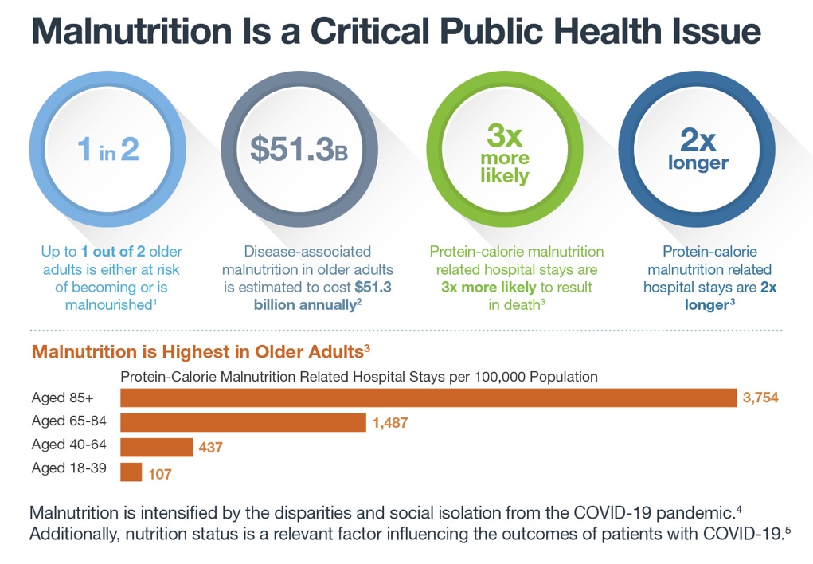
Malnutrition care is recognized
as an important gap area
Advancing Policies for Quality Malnutrition Care in Older Adults through State Actions

• There are no national or state public
health goals on malnutrition
• Malnutrition quality measures are not
included in quality incentive programs
Disease-associated malnutrition in
older adults is a state economic burden
Twelve states have an annual economic burden
of over $100 million for disease-associated
malnutrition in older adults. Disease-associated
malnutrition occurs when nutrient intake
decreases and inflammatory responses increase.⁷
State legislators can take action
Proactive legislative and public health policy
actions can help ensure quality malnutrition care
is included in preventive and social services,
patient safety, care transitions, and population
health strategies for older adults.
State Economic Burden of Disease-Associated
Malnutrition in Older Adults⁶

The national cost of malnutrition: $4.3 Billion
___________________________________________________
State: [Insert State name]
Cost of malnutrition for the state: $ [Insert cost of State-specific dollar amount. Refer to chart in The State Legislative Toolkit]
State initiatives on malnutrition: [List your state’s initiatives on malnutrition]
Call to action: [List your state-specific call-to-action]
State policy actions can include:
• Recognition of Malnutrition Awareness WeekTM ⁸
through a resolution
• Including malnutrition care in state healthcare
quality improvement initiatives
[insert state seal]
• Establishing a malnutrition prevention
commission for older adults

• For more information visit
www.defeatmalnutrition.today
• To download a free state malnutrition advocacy
toolkit visit bit.ly/state-toolkit
• To learn about the National Blueprint: Achieving
Quality Malnutrition Care for Older Adults, 2020
Update visit www.defeatmalnutrition.today/blueprint

References:
¹ Kaiser MJ, et al. J Am Geriatr Soc. 2010;58(9):1734-1738. | ² Snider JT, et al. JPEN. 2014;38(2 Suppl):77s-85s. | ³ Barrett ML, et al. US Agency for Healthcare Research and Quality. https://www.hcup-us.ahrq.gov/reports/HCUPMalnutritionHospReport_083018.pdf. Published August 30, 2018. | ⁴ Defeat Malnutrition Today. COVID-19 and Older Adult Malnutrition. https://www.defeatmalnutrition.today/covid-19. | ⁵ Laviano A, et al. Nutrition. 2020;110834. | ⁶ Goates S, et al. PLoS ONE. 2016;11(9):e0161833. | ⁷ Jensen GL, et al. J Parenter Enteral Nutr. 2010;34(2):156-159. | ⁸ American Society for Parenteral and Enteral Nutrition. Malnutrition Awareness WeekTM. http://www.nutritioncare.org/maw/.

